Exp.No:24
24. Perform Sharpening of Image using High-Boost Masks.

Aim:
To sharpen an image using the High-Boost Masking technique using OpenCV.
Procedure:
- Read the image BMW_Nature.jpg.
- Create a blurred version using Gaussian Blur.
- Create the mask by subtracting the blurred image from the original.
- Multiply the mask by a high-boost factor.
- Add the enhanced mask to the original image.
- Display the original and sharpened images.
- Save the output image.
Program:
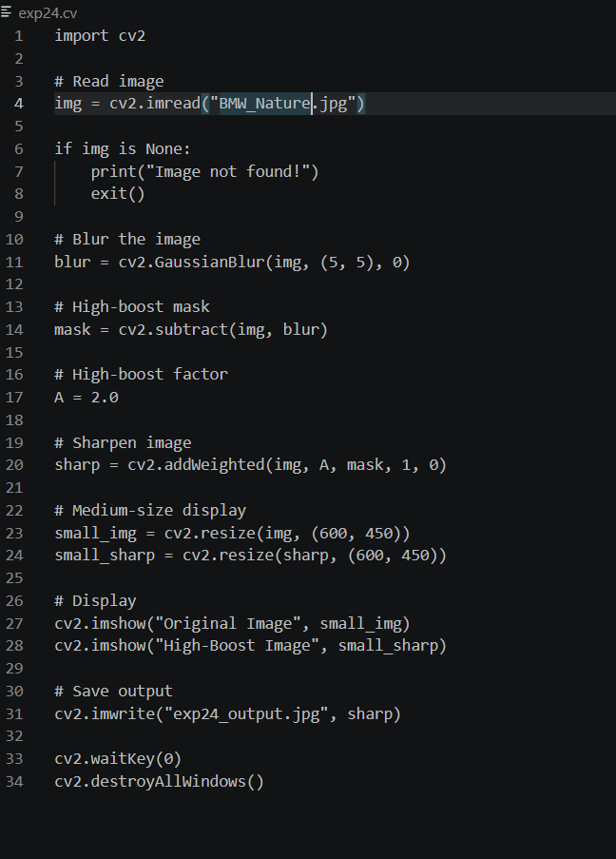
Input:
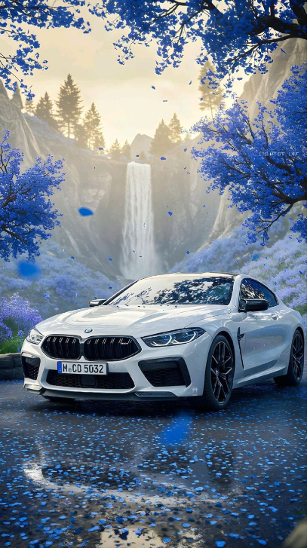

Output:
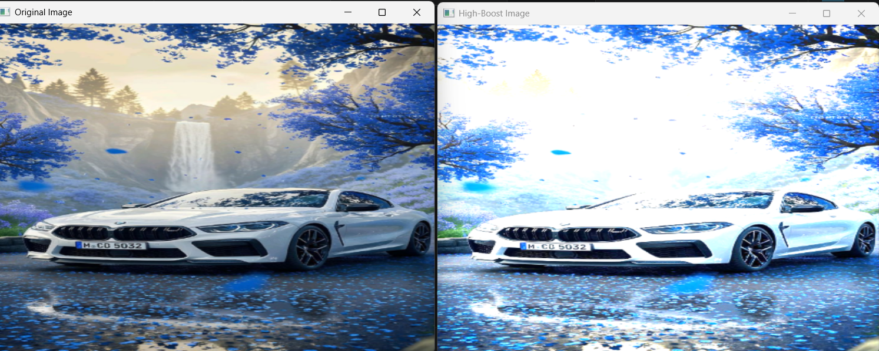

Result:
The image was successfully sharpened using the High-Boost Masking technique.

